TASK04-02: Declarative pipeline
stages:
- Git Clone
- SonarQube Integration
- Maven Compilation
- Nexus Artifactory
- Slack Notification
- Deploy On tomcat

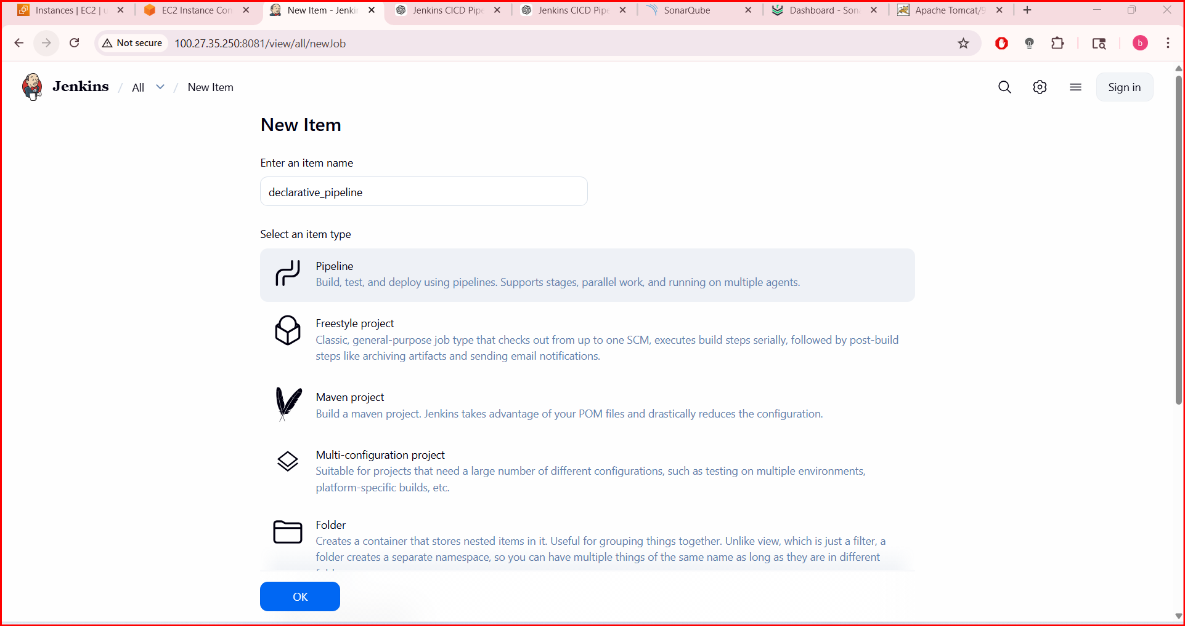
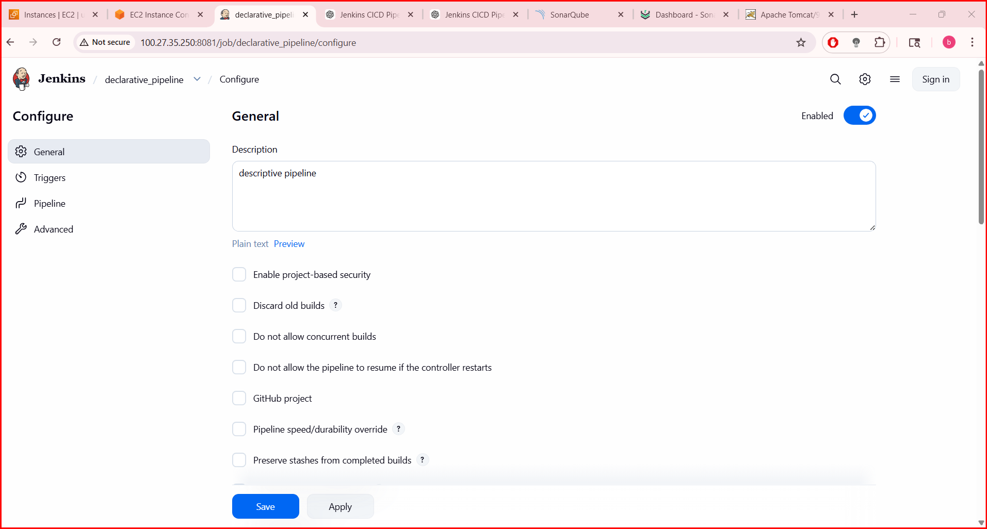
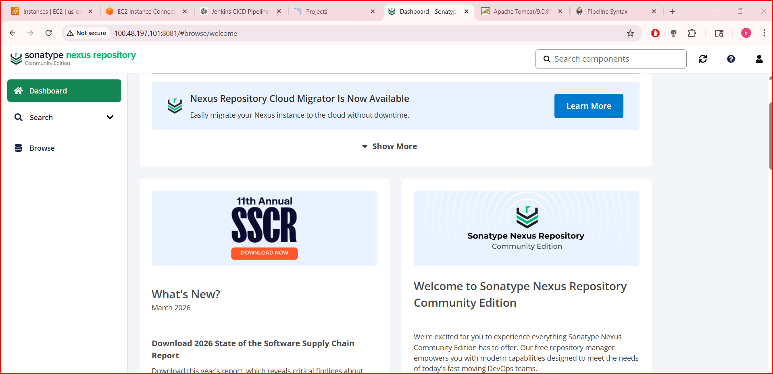
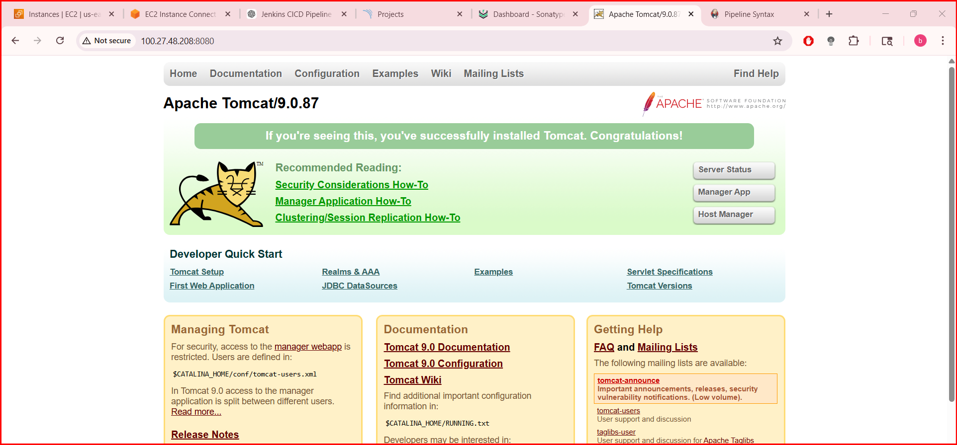
pipeline {
agent ‘Horizon’

tools {
maven 'Maven'
jdk 'JDK'
}

environment {
SONAR_HOME = tool 'SonarQubeScanner'
}

stages {

stage('Git Clone') {
steps {
git branch: 'feature-1.1',
url: 'https://github.com/betawins/sabear_simplecutomerapp.git'
}
}

stage('SonarQube Analysis') {
steps {
withSonarQubeEnv('SonarQube') {
sh """
${SONAR_HOME}/bin/sonar-scanner \
-Dsonar.projectKey=sabear \
-Dsonar.sources=. \
-Dsonar.java.binaries=target
"""
}
}
}

stage('Maven Build') {
steps {
sh 'mvn clean package'
}
}

stage('Upload to Nexus') {
steps {
nexusArtifactUploader(
nexusVersion: 'nexus3',
protocol: 'http',
nexusUrl: 'YOUR-NEXUS-IP:8081',
groupId: 'com.sabear',
version: '1.0',
repository: 'maven-releases',
credentialsId: 'nexus-cred',
artifacts: [
[
artifactId: 'sabear-app',
classifier: '',
file: 'target/*.war',
type: 'war'
]
]
)
}
}

stage('Deploy to Tomcat') {
steps {
deploy(
adapters: [
tomcat9(
credentialsId: 'tomcat-cred',
path: '',
url: 'http://YOUR-TOMCAT-IP:8080'
)
],
contextPath: 'sabear',
war: 'target/*.war'
)
}
}
}

post {
success {
slackSend(
channel: '#jenkins',
color: 'good',
message: "SUCCESS: ${env.JOB_NAME} - ${env.BUILD_NUMBER}"
)
}
failure {
slackSend(
channel: '#jenkins',
color: 'danger',
message: "FAILED: ${env.JOB_NAME} - ${env.BUILD_NUMBER}"
)
}
}
}
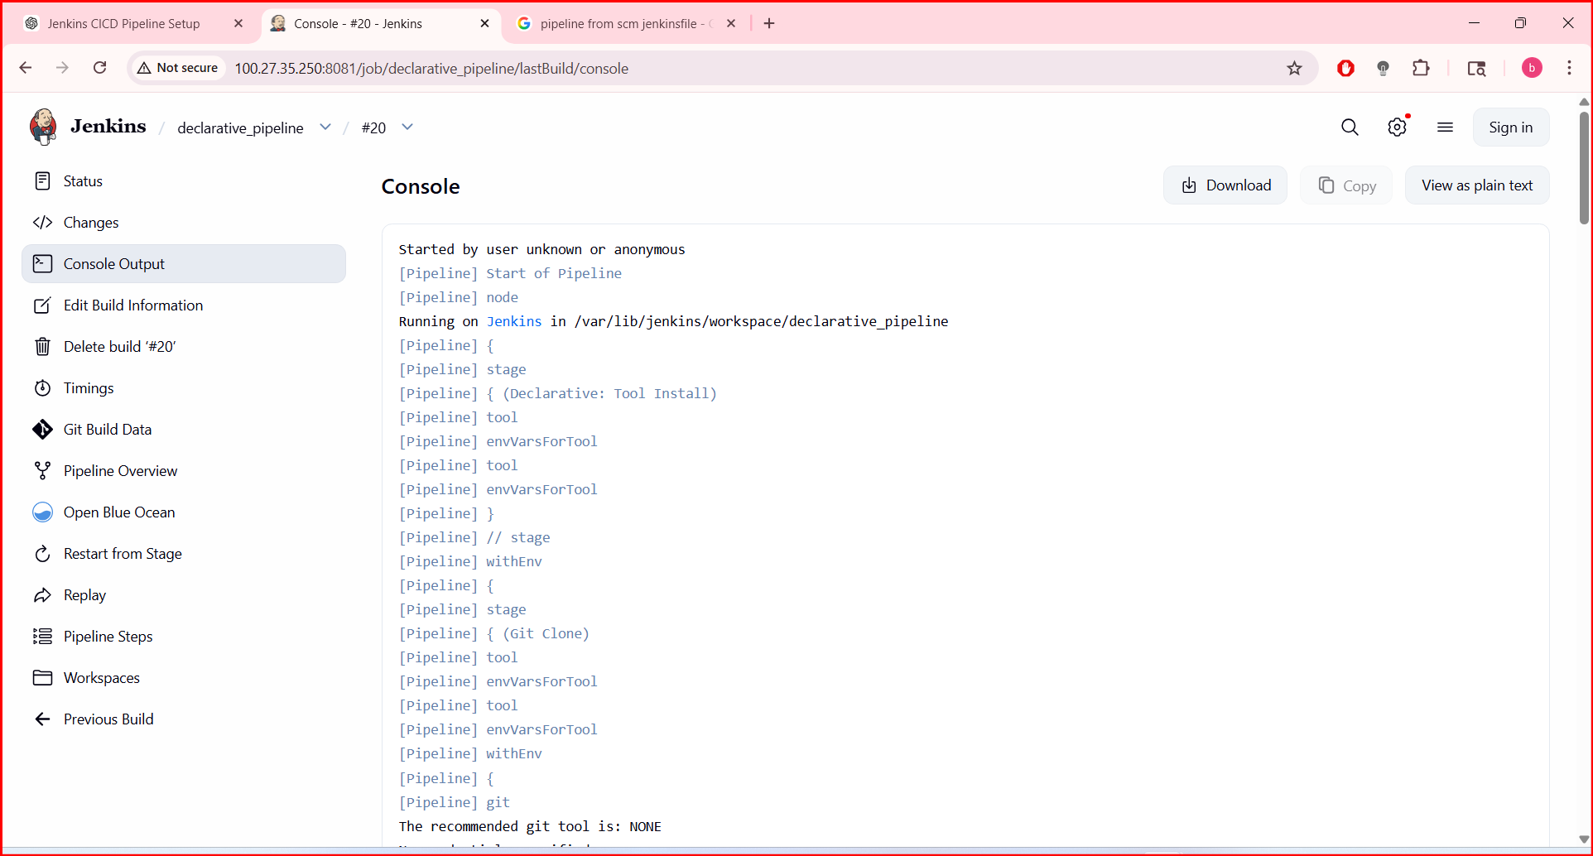
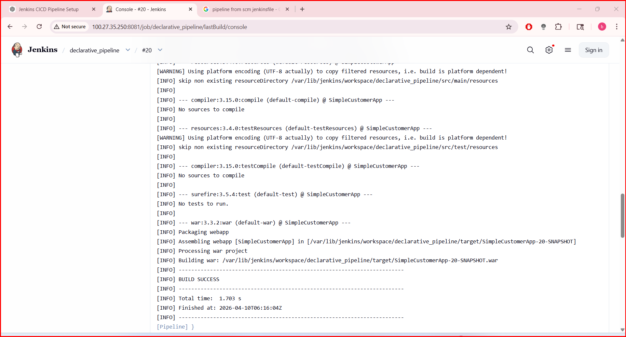
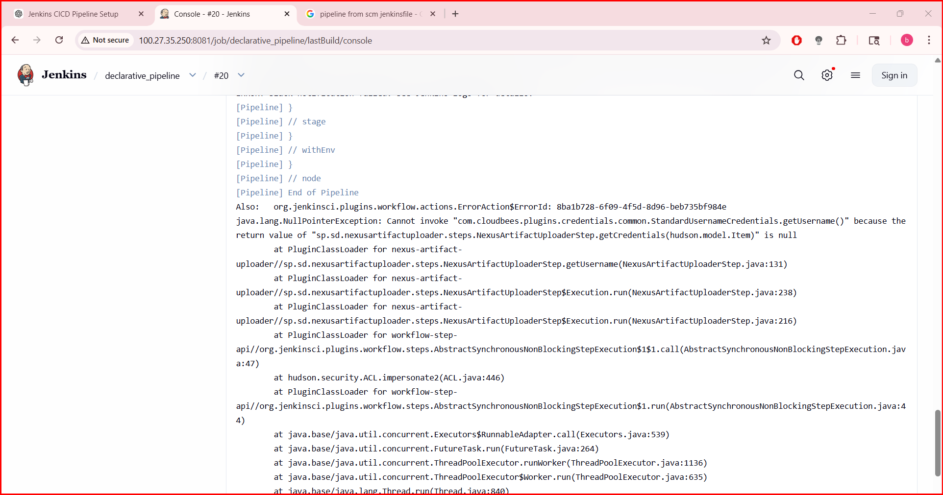
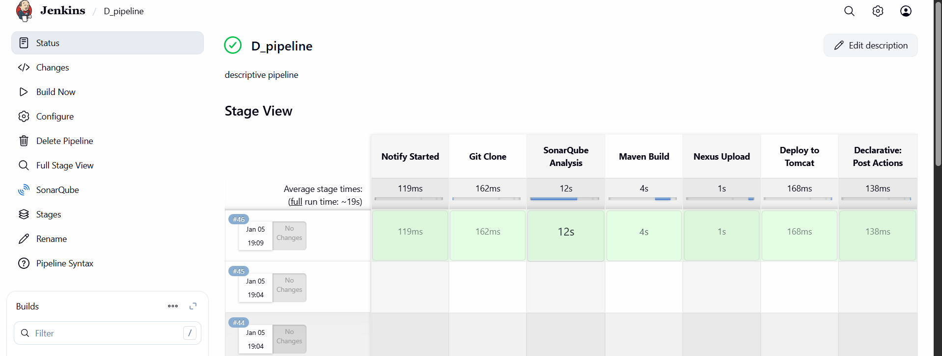
- 4. Write sample skeleton of pipelines.
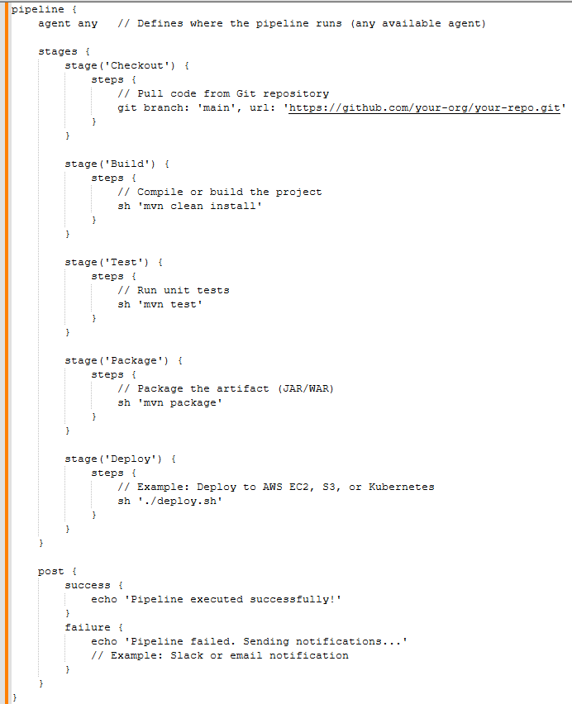
Title:
5. Create a parameterized job in Jenkins. https://github.com/betawins/spring3-mvc-maven-xml-hello-world-1.git
Objective
The objective is to make the CI/CD pipeline flexible and reusable. By using parameters, you can use a single job to:
- Select Branches: Build any Git branch or tag dynamically.
- Target Environments: Choose between DEV, QA, or PROD at runtime.
- Toggle Features: Decide whether to run specific stages, like SonarQube or Nexus uploads, using checkboxes.
Implementation::
Navigate to Jenkins and click on new item
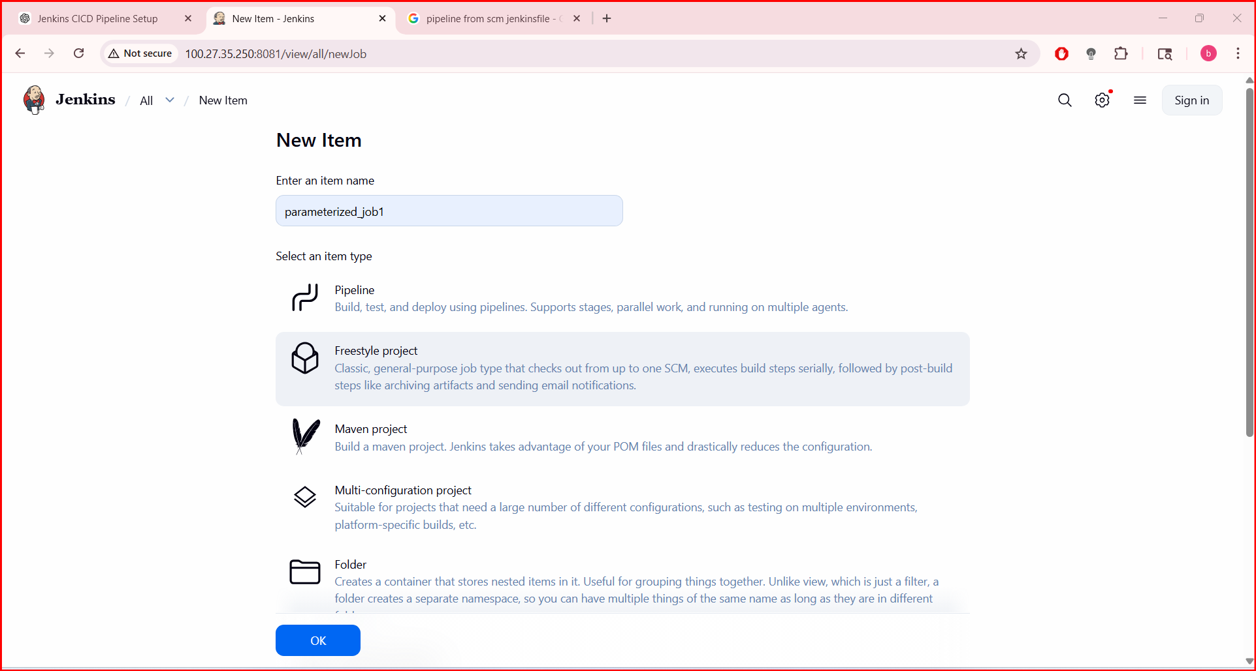
- Add git branch and branch name from the repo which are available

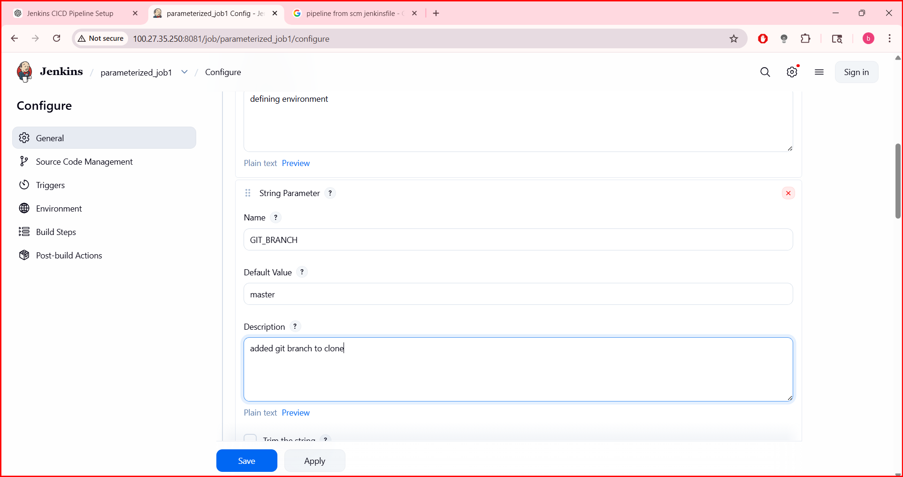
- After that add source code management and add git repo url and continue

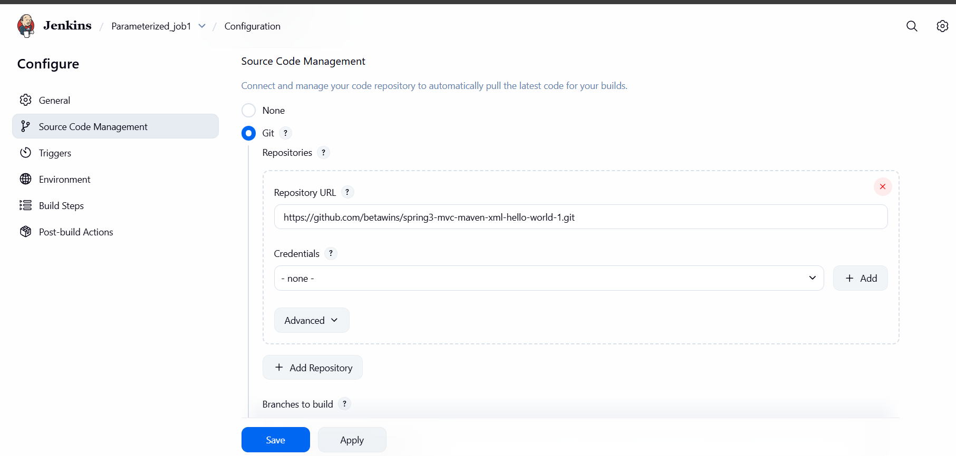
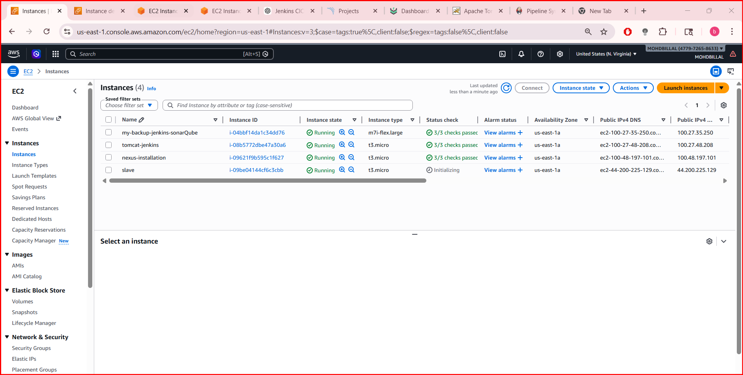
- 6. Setup one slave machine for Jenkins.
- Launch an dedicated instance for slave
